Graphics and Animation Tools
LAB
Experiment – 3 Design of Google Logo using GIMP.

Step – 1:

Open GIMP, go to file → new file → choose 1920x1920 size screen with white as background.
And select the fill with transparency.

Step – 2:

Go to image → guide → guide by percent → (horizontal & vertically 50 percent) → OK

Step – 3:

Go to View → Enable Snap to Guide and Snap to Canvas edges.

Step – 4:

Grab the ellipse select tool, start creating a circle at the center and hold ctrl+shift to create an image covering whole canvas (which creates perfect symmetrical circle.)
Go to Select → to path
Go to Select → NONE.
Go to Path Box on the right hand side and enable the eye on the selected path.
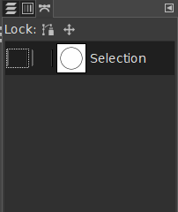

Step – 5:

Choose the Text tool and type in “Fast Browser” and “Google chrome”

Step – 6:

Select Fast Browser and then right click on the Layer and select TEXT ALONG PATH.

Step – 7:

Create New Layer, turn of the visibility of the text layer, Go to the path menu, select the path(Fast Browser), Fill it with BG color(either directly from the drop down menu or from the Edit menu)

Step – 8:

Now select the Flip tool, Under that select path icon and select horizontal → now click on the circular Path → Set the Flip tool back to default. AND REPEAT STEP 4&5 FOR GOOGLE CHROME.

Step – 9:

Turn off the visibility of the circular path so that only the text is visible.
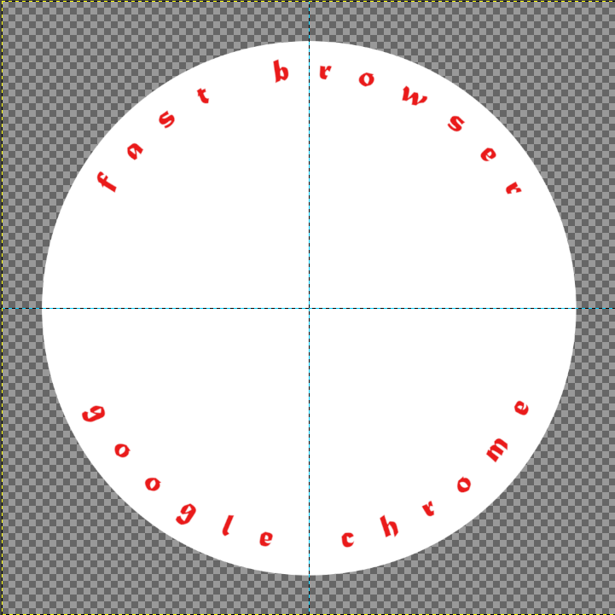

Step – 10:

Now insert the Google Logo in Middle of the Text and Scale it to your requirement.



Step – 11:

Now to cut the extra area coming out of the Circle, Click on the background layer → Alpha to selection → Select → Invert → Click on the Extra layer → delete → Select NONE

